# **Sprint 3 Plan Thru-Hiker** Sprint completion date: 5/27/24 Revision 1, 5/15/24

### **Goal:**

Add more interactivity through achievements, points of interests, and more engaging UI.

### **Tasks:**

* + **High Priority User Story 2.1 [8 points]**

As a user, I want to receive alerts on landmarks or points of interest I've passed through my hike after my workouts.

* + **Medium Priority User Story 2.2 [5 points]**

As a user, I want to save logs of my in-progress and completed hikes so that I can review my achievements and share them with others.

* + **Low Priority User Story 2.3 [3 points]**

As a user, I want to see more visuals and metrics for the progress I am making.

Task 1: Implement page for landmarks and POI passed each day.

Task 2: Page that shows completed routes and achievements on those routes.

Task 3: Add more information to the map UI such as progress meters, expected finish date, miles per day, etc

### **Roles:**

Gavin: Backend Lead

Kai: Front End Lead

Brandon: Developer/Scrum Master

Ayman: Developer

Taylor: Developer

### **Task Assignment:**

Gavin: User story/Task 1

Kai: User story/Task 2

Brandon: User story/Task 3

Ayman: User story/Task 2

Taylor: User story/Task 1

### **Initial burndown:**

### **Initial scrum board:**

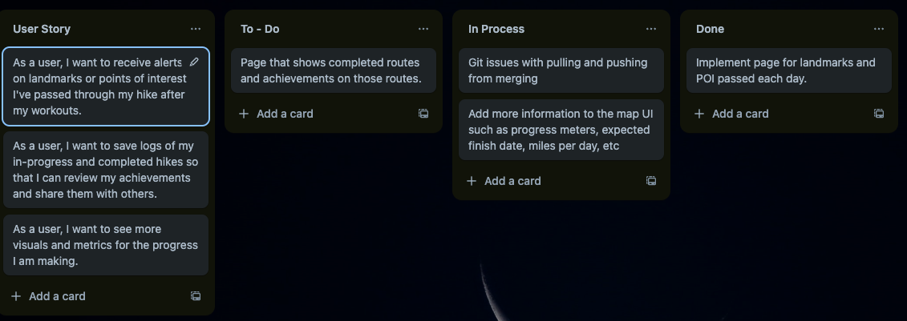

### **Scrum time:**

Monday, Wednesday, Friday 12-1pm. TA meeting on Friday 12-1pm.